ACT Fire & Rescue Community Fire Units
Drills

CONTENTS
PRACTICAL DRILLS:

- CFU Terminology pg. 2
- Visual Equipment Glossary pg. 3
- 1. Basic trailer and content identification pg. 4
- 2. Basic WET hose drill pg. 5
- 3. Breaching and damaged hose replacement pg. 6
- 4. Static water supply pumping pg. 8
- 5. Team leader communications with COMCEN pg. 9

COMMUNICATIONS DRILLS pg. 10
- 1. Hand signals pg. 12
- 2. Radio check pg. 13
- 3. General Emergency drill pg. 14
- 4. Reporting a fire pg. 15
- 5. Internal Unit COMS drill pg. 16
- Training Record pg. 17
- Training Record Example pg. 18

CFU Useful Terminology

Terms to familiarise yourself with:

- STILL – Safely cease all operations immediately. This direction may be issued by any member on the training ground and used when a member is at risk of injury for example.

- CARRY ON – Continue what you were doing.

- GET TO WORK – Start exercise or scenario.

- MAKE UP – Tidy, clean and stow equipment away.

- EMERGENCY WARNING HORN – 3 X short blasts on the air horn means you cease all operations immediately and proceed to the nominated safety zone (For example, your CFU Trailer).

Remember, always ensure correct Personal Protective Clothing and Equipment is worn on the fire ground.

For your safety and to ensure a successful day of training please familiarise yourself with the following risks and preventative measures.

- Evacuation / Cease Operations – Proceed to identified safety zone (for example the trailer) and await instruction.
- Weather – Ensure re-hydration, sunscreen, and head covering is used to protect from falling object caused by heavy wind.
- Slips, trips and falls – Familiarise yourself with the drill area and identify any trip hazards. Be aware that the drill area may be wet and slippery at times. Ensure correct footwear is worn.
- Drill Yard – Be aware of vehicle and people movements on/around the drill area.
- Manual Handling – Do not attempt to move or lift heavy equipment individually, always ask for assistance. If unsure notify your Team Leader for advice.
- Water Pressure – Water pressure can be a danger if not handled with care. Ensure you use the equipment correctly and all hose connections and standpipe are fitted correctly and locked in place.

Visual Equipment Glossary

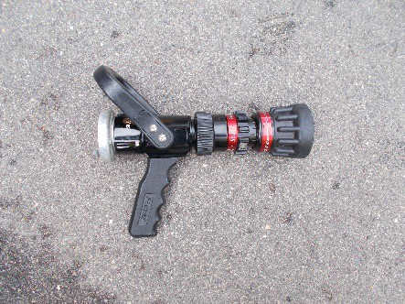  Protek branch | 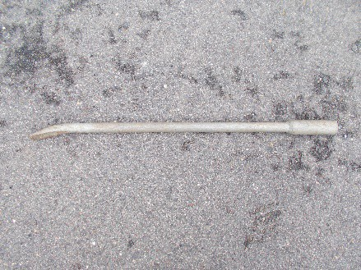  Hydrant bar
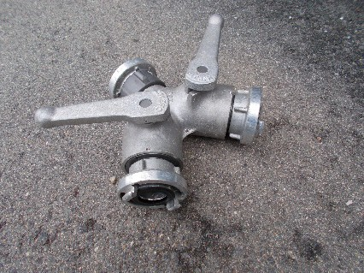  Gated breach | 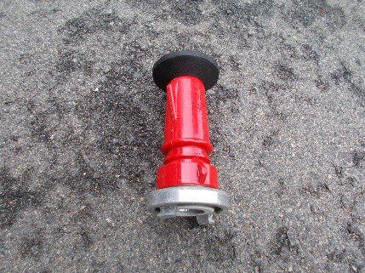  Red diffuser
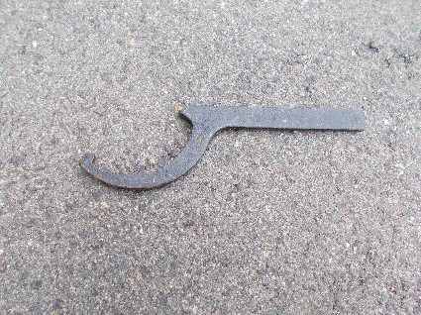  C-spanner | 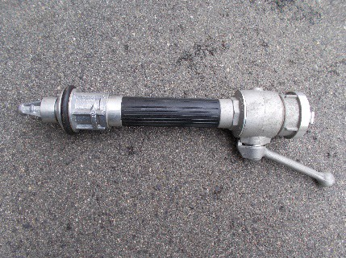  AWG
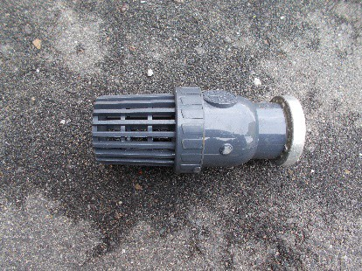  Strainer (one way valve) | 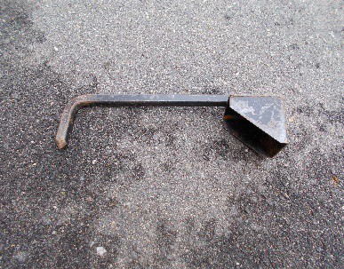  Hydrant scoop
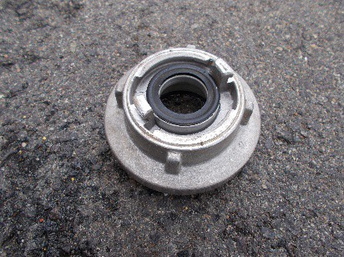  64-38 adaptor | 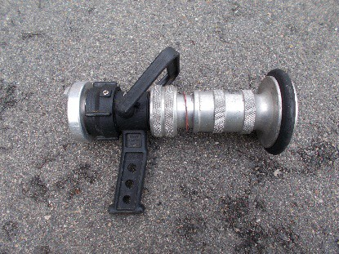  Metal branch diffuser
Drill One Basic trailer and content identification:

Drill One Basic trailer and content identification: | Aim of drill:  - The aim of this drill is to ensure all members are familiar with the layout of their unit trailer as per the inventory. This will ensure that in the event of an emergency, each member will be able to locate any piece of equipment without much time delay.  - This drill can be completed in any location away from public traffic (e.g. a drive way)  Demonstrate:  - Correct identification of all equipment and its location within the unit trailer  - Identification of missing/broken equipment (To be reported to CFU coordination team)
Practical resources: | CFU trailer:  - All contents of trailer
Safety Considerations: | - Define exclusion zones  - Public traffic  - Clear communication to members – visual or through use of radio  - Safety Officer (usually Team leader unless otherwise designated)  - If member is uncomfortable with any part of the exercise, they should advise the Team leader
PPE/PPC for members: | - CFU issued:  - CFU Tunic and pants  - Gloves  - Boots  - Helmet  - Goggles

Drill Two Basic WET hose drill:

Drill Two Basic WET hose drill: | Aim of drill:  - The aim of this drill is to ensure members can safely and correctly:  - shipping a standpipe;  - bowling hose;  - connecting hose to a standpipe and branch; and  - the correct use of hand signals and use of Benelec radios.  Demonstrate:  - Ship a standpipe ensuring the hydrant pit is checked for serviceability and cleanliness (i.e. free from spiders, snakes or ants’ nests etc)  - Bowl and roll a 38mm hose  - Connect 1 x length of 38mm hose to the standpipe and connect two hoses together  - Connect a branch to the 38mm hose (hose should not be charged/on)  - Use correct hand signals – water on/off  - Use Benelec radios where appropriate and using C.A.N format  - Turn water on (WET), ensuring branch is closed  - Open branch and direct water stream in a controlled manner  - Make up equipment
Practical resources: | CFU trailer:  - 1x 38mm branch and hose  - 2 x 38mm hose | - Stand pipe  - 5x Benelec Radios  - CFU training sign
Safety Considerations: | - Define exclusion zones  - Public traffic  - Clear communication to members – visual or through use of radio  - Safety Officer (usually Team leader unless otherwise designated)  - If member is uncomfortable with any part of the exercise, they should advise the Team leader
PPE/PPC for members: | - CFU issued:  - CFU Tunic and pants  - Helmets  - Gloves  - Boots  - Goggles

Drill Three Breaching and damaged hose replacement

Drill Three Breaching and damaged hose replacement: | Aim of drill:  - The aim of this drill is to ensure all members are familiar with the process of setting up a breach on a standpipe and be able to run 2 x lines of hose from a single standpipe.  - All members should be aware of how to replace a damaged hose during an incident.  Demonstrate:  - Ship a standpipe  - Connect a 38mm gated breach to the standpipe  - Bowl and roll 4 x 38mm hose  - Connect 2 x lines of hose to each breach and connect a branch to each connected hose (hose should not be charged/on)  - Demonstrate correct hand signals – water on/off  - Use Benelec radios for communication where appropriate  - Turn water on (WET), ensuring branch is closed  - Open branch and direct water stream in a controlled manner  - Team leader to nominate a line of hose to replace  - One nominated member to bowl new length of hose parallel to damaged hose  - Standpipe operator to shut off water to the affected line at the breach  - Members on affected line to leave branch open to drain water, disconnect damaged line and replace with new line of hose.  (An overhand knot should be tied in the damaged length and reported to CFU coordination team)  - Close branch  - Water on – Standpipe operator to reinstate water supply on breach  - Make up equipment  (NOTE: This drill can be performed with one line of hose with the gated breach isolated on the unused side if membership attendance is low)
Practical resources: | CFU trailer:  - 1 – 2 x 38mm branch  - 3 – 6 x 38mm hose |  | - Standpipe  - Gated breach (as required |  | - 5x Benelec Radio  - CFU training sign  - Traffic cones
Safety Considerations: |  | - Define exclusion zones  - Public traffic  - Clear communication to members – visual or through use of radio  - Safety Officer (usually Team leader unless otherwise designated)  - If member is uncomfortable with any part of the exercise, they should advise the Team leader
PPE/PPC for members: |  | - CFU issued:  - CFU Tunic and pants  - Helmets |  | - Gloves  - Boots  - Goggles

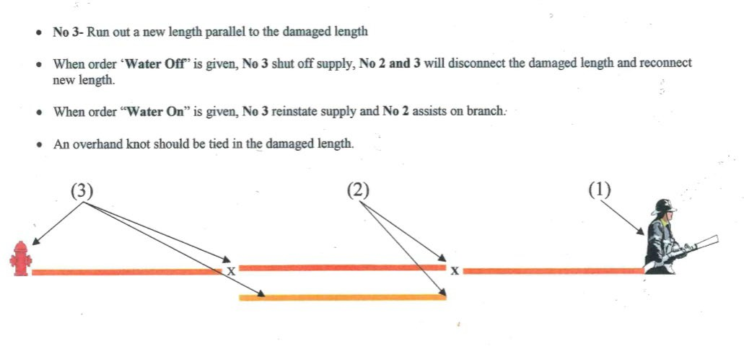

Drill Four Static water supply pumping:

Drill Four Static water supply pumping: | Aim of drill:  - The aim of this drill is to ensure all members are familiar with the process of obtaining water from a static water supply (e.g. a pool or domestic water tank)  Demonstrate:  - Identify various components of CFU petrol pump and carry out checks  - Fill pump with a bucket of water for priming  - Set-up pump for suction pumping at an appropriate static water supply  - Connect 2 x lengths of 38mm suction hose together, attaching strainer at end of hose to be immersed in water supply  - Connect suction hoses to collector of pump  - Connect 1x length of 38mm hose to pump delivery (fold hose over pump so water does not run into hose line)  - Connect branch to 38mm hose  - Use correct hand signals – water/pump on/off  - Use Benelec radios where appropriate and using C.A.N format  - Make sure branch operator is ready before engaging the pump  - Engage pump (WET), ensuring branch is open  - Shut down pump and drain the hose line  - Make up equipment
Practical resources: | CFU trailer:  - 1x 38mm branch and hose | - CFU petrol pump  - Bucket of water  - 2 x 38mm hose | - 5x Benelec Radio  - CFU training sign
Safety Considerations: | - Define exclusion zones  - Public traffic  - Clear communication to members – visual or through use of radio  - Safety Officer (usually Team leader unless otherwise designated)  - If member is uncomfortable with any part of the exercise, they should advise the Team leader
PPE/PPC for members: | - CFU issued:  - CFU Tunic and pants  - Helmets  - Gloves  - Boots  - Goggles

Drill Five Team Leaders Communications with Comcen:

Drill Five Team Leaders Communications with Comcen: | Aim of drill:  - The aim of this drill is to ensure team leaders are familiar with the procedures when communicating with ACTF&R Incident controllers and ACTF&R Comcen  Demonstrate:  - Contact ACTF&R Comcen on 62004111 to request monitoring Ops 5  - Send messages to Comcen on Harris Radio (see team leader document or COMS drill section)  - Use Conditions Action’s Needs (C.A.N) reporting procedure.
Practical resources: | CFU trailer:  - 1x ACTF&R Harris Radio
Safety Considerations: | - Public Traffic
PPE/PPC for members: | - Not applicable

Communications Drills

Situation Reports

On arrival at your chosen/designated location, the team leader should provide an initial situation report (sitrep) to COMCEN in order to provide COMCEN and other attending units with a “picture” of the incident itself.
A Sitrep should include the following:

Identify your unit number (e.g. CFU01),
- How many members of your unit are present,
- Where you are located,
- What you see; and
- What are you tasking your team to do.

NOTE: Only identify your name once. Use your CFU number for all ongoing communication with COMCEN
For example:
  - CFU01: COMCEN this is CFU01, SITREP
  - COMCEN: CFU01 this is COMCEN, pass your SITREP
  - CFU01: COMCEN this is CFU01, we have 5 members of CFU01 activated and are on scene at 123 Smiths Street, Chapman. We have a small grass fire behind 123 Smiths Street and are deploying two teams of two along both sides of 123 Smiths Street to extinguish the grass fire.
  - COMCEN: Received CFU01, you have 5 members of CFU01 activated and are on scene at 123 Smiths Street, Chapman. You have a small grass fire behind 123 Smiths Street and are deploying two teams of two along both sides of 123 Smiths Street to extinguish the grass fire.
NOTE: Once you have completed a training or operational activity, the Team Leader is to inform COMCEN using the Harris Radio

For example:
- CFU01: COMCEN this is CFU01, we have completed our training exercise and are making up equipment.
- COMCEN: CFU01 this is COMCEN, you have completed our training exercise and are making up equipment – COMC CLEAR

Conditions, Actions, Needs (CAN) Reports

After the situation report on arrival, all other status reports, including an emergency communication, follow the Conditions, Actions, Needs format.

The Team leader provides CAN reports when:

When a strategic objective has been met or the plan/activities change.
- When further assistance is required.
- When there is an emergency – e.g. a CFU member is injured, missing or cannot be accounted for.

CFU members or Sector leaders provide CAN reports regarding their sector to the Team leader as requested, or when:

A new critical factor is discovered.
- A previous task is complete, and the unit is ready for re-tasking.
- If, for some reason, the task allocated cannot be completed.

CAN Reporting
  - CAN reporting keeps things simple and it delivers the team leader the information needed to keep the strategy and plan current.

C.A.N REPORTS
CONDITIONS (What you see)

ACTIONS (What you are doing/going to do)

NEEDS (What resources do you need –
e.g. Need more hose)

Drill One Basic Hand Signals:

Drill One Basic Hand Signals: | Aim of drill:  - To demonstrate the use of hand signals for communication.  Demonstrate:  - Ship a standpipe ensuring hydrant pit is clean  - Bowl 2 x lengths of 38mm hose  - Connect hoses together.  - Connect one end to the standpipe and a branch to the other end  - Use correct HAND SIGNALS – water on/off.  - Make up equipment |  | - Water on  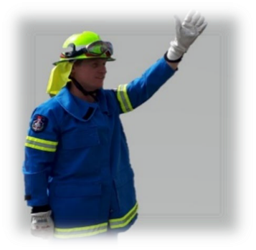  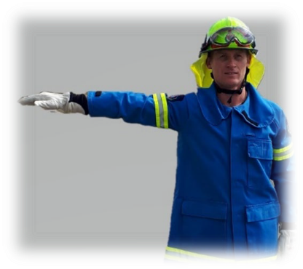  - Water off
Practical resources: | CFU trailer:  - 2 x length 38mm hose | - 1 x standpipe  - 1 x branch |  | - CFU training sign  - Traffic cones
Safety Considerations: | - Define exclusion zones  - Public traffic  - Clear communication to members – visual or through use of radio  - Safety Officer (usually Team leader unless otherwise designated)  - If member is uncomfortable with any part of the exercise, they should advise the Team leader
PPE/PPC for members: | - CFU issued:  - CFU Tunic and pants  - Helmets  - Gloves  - Boots  - Goggles

Drill Two Radio Check with COMCEN:

Drill Two Radio Check with COMCEN: | Aim of drill:  - To demonstrate the process for establishing communications with COMCEN (RADIO CHECK).  Demonstrate:  - Remove HARRIS radio from CFU trailer  - Turn radio on and check battery strength  - If battery does not have enough charge, proceed to local fire station  to replace battery. (Take CFU ID card when changing battery)  - Select correct radio talk group (Position 1) which is connected to ACTF&R OPS 5  - Activate press to talk (PTT) button and repeat the following:  - COMCEN this is CFU (unit number)  - COMCEN will reply acknowledging your message by repeating your callsign. If COMCEN do not reply after 30 seconds, either repeat the message or ring COMCEN (62004111) and advise them your radio message was not acknowledged. When COMCEN acknowledge, relay the following message:  - COMCEN, THIS IS CFU (unit number) requesting radio check, how do you receive?  - COMCEN will reply advising you how they received your radio message, you will then reply;  - COMCEN, CFU (unit number) received, reading you 5 by 5 (# out of 5 for clarity), CFU (unit number) out.
Practical resources: | - CFU Harris Radio
PPE/PPC for members: | - Not applicable

Drill Three General Emergency drill with COMCEN:

Drill Three General Emergency drill with COMCEN: | Aim of drill:  - To demonstrate that emergency radio communications can be established with COMCEN (RADIO CHECK).  Demonstrate:  - Remove handheld HARRIS radio from CFU trailer  - Turn radio on and check battery strength  - If battery does not have enough charge, proceed to local fire station to replace battery. Take CFU ID card when changing battery  - Select correct radio channel position 1 (ACTF&R OPS 5).  - Activate press to talk (PTT) button and repeat the following  - COMCEN this is CFU (unit number) “FOR DRILL PURPOSES ONLY  RED RED RED”  - COMCEN will reply acknowledging your request to send a red message  - If COMCEN do not reply, repeat the message  In the event of an actual fire or emergency ring COMCEN on 000  Any of these scenarios can be used for this drill:  - COMCEN, CFU (unit number), for drill purposes only, we require urgent assistance at (add detail)  - COMCEN will reply advising you they received your radio message, and may request further details  - COMCEN, CFU (unit number), for drill purposes only, we require an ambulance and/or fire appliance at (add address/location  - COMCEN will reply advising you they received your radio message, and may request further details
Practical resources: | - CFU Harris Radio
Safety Considerations | - COMCEN MUST be notified before this drill is undertaken. Any radio communications must be prefaced by a comment that this is for drill purposes only
PPE/PPC for members: | - Not applicable

Drill Four Reporting a fire:

Drill Four Reporting a fire: | Aim of drill:  - To demonstrate that emergency radio communications can be established with COMCEN.  Demonstrate:  - Remove handheld HARRIS radio from CFU trailer  - Turn radio on and check battery strength  - If battery does not have enough charge, , proceed to local fire station to replace battery. Take CFU ID card when changing battery  - Select correct radio channel position 1 (ACTF&R OPS 5).  - Activate press to talk (PTT) button and repeat the following:  - COMCEN this is CFU (unit number) Sit rep  - COMCEN will reply acknowledging your request to send a Sit Rep  message  - If COMCEN do not reply, repeat the message  - COMCEN, CFU (unit number), for drill purposes only, there is a fire at (add address/location)  - COMCEN will reply advising you they received your radio message, and may request further details  In the event of an actual fire or emergency ring COMCEN on 000
Practical resources: | - CFU Harris Radio
Safety Considerations | - COMCEN MUST be notified before this drill is undertaken. Any radio communications must be prefaced by a comment that this is for drill purposes only
PPE/PPC for members: | - Not applicable

Drill Five Internal Unit COMS drill:

Drill Five Internal Unit COMS drill: | Aim of drill:  - To demonstrate that radio communications can be established within your unit using Benelec radios.  Demonstrate:  - Remove Benelec radios from CFU trailer  - Turn radio on and check battery strength  - If battery does not have enough charge, follow procedures to change/charge battery  - Nominate a talk around channel  - Ensure all Benelec radios are on the same channel  - Make sure you know the limits of your radios i.e. distance between radios (approx. 2km)  - Activate press to talk (PTT) button and communicate between radio users  Note -There are no limits on using Benelec radios apart from public decency  - Try using the Benelec radios for activities like:  - Requesting water on  - Requesting water off  - Asking for more hose  - Advising the team leader that a fire appliance has arrived  - Anything that needs to be communicated and can’t be done face to face
Practical resources: | - CFU Benelec Radio
Safety Considerations | - Not applicable
PPE/PPC for members: | - Not applicable

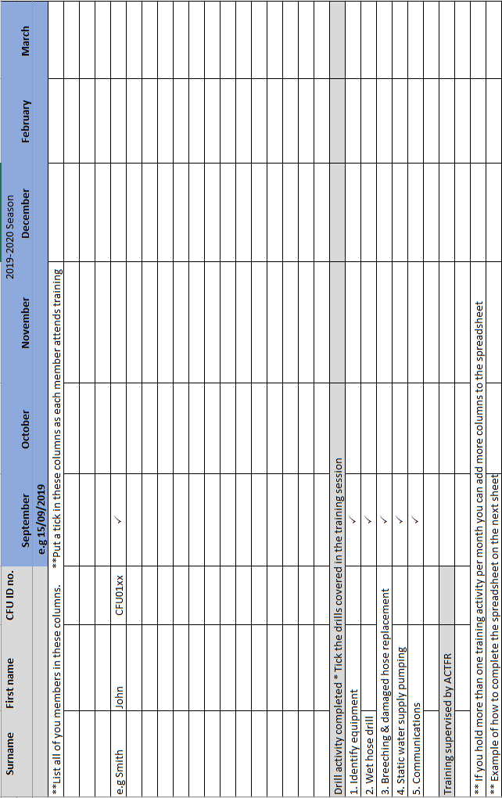
Please go to the ACTF&R CFU website to access a BLANK COPY under the heading “documents”
